DAD 220 Project Two Template

Overview
Review the scenario for this activity in the guidelines and rubric. Then complete the steps below as you work through the directions for this activity. Replace the bracketed text with your screenshots and responses to the prompts. Size each screenshot and its explanation to fit approximately one-quarter of the page with the description written below the screenshot. Review the Template Screenshot Example linked in the guidelines and rubric for this assignment to see an example of how screenshots for your assignment should look.

RMA Report
Write a report to respond to the manager’s requests. In the report, you should complete the following actions:

- Summarize the data you’ve been working with.
- Identify key information that will help the company streamline operations.

Your report should explain your findings in a way nontechnical stakeholders can understand and use.

Use the steps below to capture the required data and produce the analysis report.

- Begin by writing SQL commands to capture specific usable data for your analysis. You already preloaded the data you need into Codio.
- Specifically, the product manager wants you to complete the following analysis:

  - Analyze the number of returns by state and describe findings to include in your report.

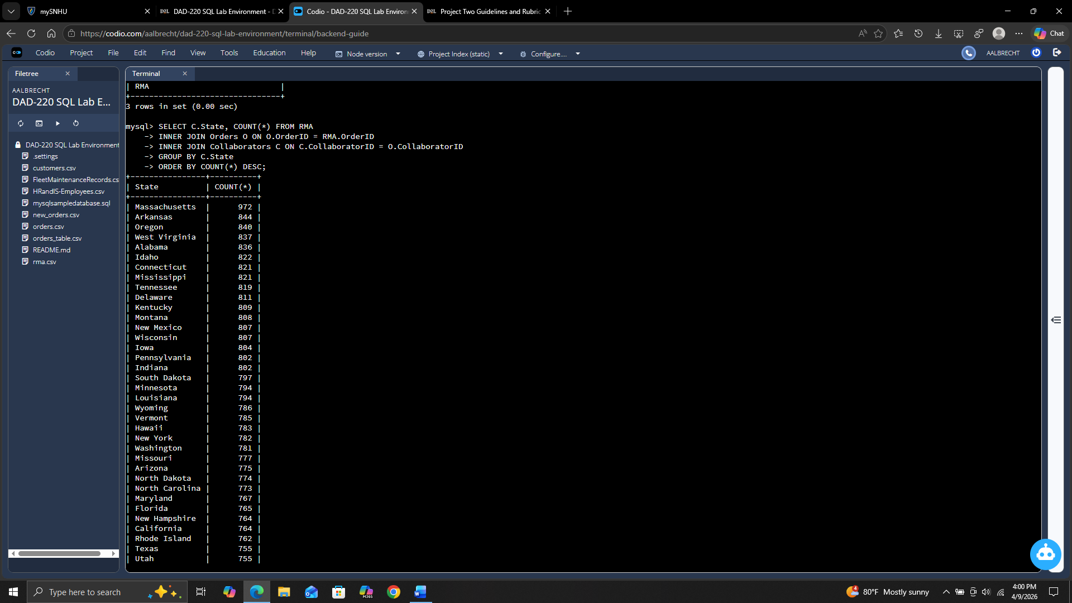
The lowest number of returns was South Carolina at 702 where the most number of returns was from Massachusetts at 972. Most states are fairly close in the number of returns between 702 and 844. Massachusetts was the only state that had a noticeable gap between their returns and the and returns of other states.

  - Analyze the percentage of returns by product type and describe findings to include in your report.

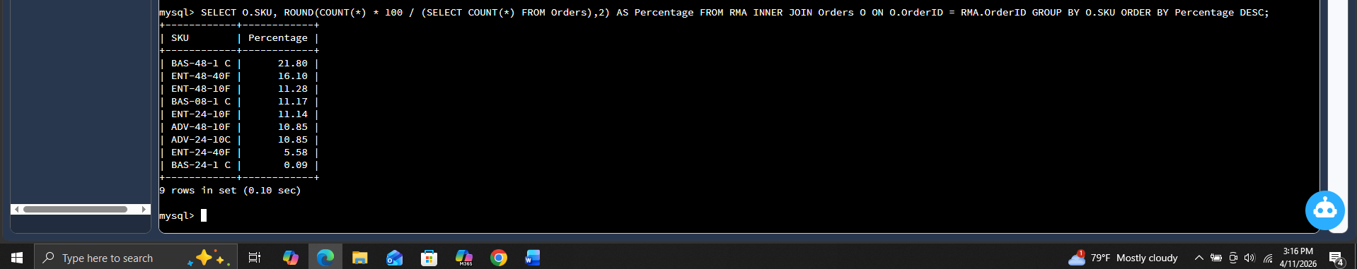
The product BAS-48-1 C had the highest percentage of returns at 21.8 percent followed by ENT-48-40F at 16.10 percent. The lowest return percentage was BAS-24-1 C at 0.09 percent.

- Write a report to clearly summarize your RMA data analysis for stakeholders. When you summarize the results, consider the following questions:

  - How does the data provide the product manager with usable information?
  - What are the potential flaws in the data that has been presented?
  - Are there any limitations on your conclusions or any other ways of looking at your findings that you haven’t considered? Clearly communicate your findings to stakeholders.

The data presented here shows a few things. Firstly, it shows which states have higher return rates compared to the others. The first thing to consider is whether the products delivered to that state are being damaged in shipping or is it the product itself. While most states had a consistent return rate compared to others, the state with the highest returns, Massachusetts, seems to be an outlier. The next thing shown in the data is that product BAS-48-1 C had the highest rate of return at 21.80% followed by ENT-48-40F at 16.10%. The next 5 products have returns between 10% and 11.3%. We need to understand why those first 2 products have an elevated return rate. Is it a defect from the manufacturer? Does the customer not understand the product? A potential flaw of the data is that when return information was entered, it was flagged under the wrong SKU. Verifying the authenticity of the data would allow dispel those doubts. This data doesn’t account for how products and returns can be affected by seasons or holidays, i.e. buying gifts for Christmas but is returned because the person receiving the gift didn’t want or changed their mind. Something else that hasn’t been accounted for is people who try to scam companies. Maybe someone had bought a product previously and bought another as it is wearing out only to switch the new one out with the old and return the old one for money back. Checking to see if any one person or company has higher return rates than others could give insight into that. While this is a good general overview of what is happening, I would suggest a more in-depth look at what is occurring if you want to get to the root of the problems. By doing this we can determine the best course of action to make sure the company stays profitable while maintaining good relations with the customer base.

